Project Development Phase
Model Performance Test

Date | 30 September 2026
Team ID | SWTID-2026-8886
Project Name | Implement Client Script and UI Policy for Incident
Maximum Marks

Model Performance Testing:
Project team shall fill the following information in model performance testing template.
S.No. | Parameter | Screenshot / Values
1 | Incident fields rendered | Impact, Urgency, Group, and Assignee shown in the conceptual form; UAT not run.
2 | Data preprocessing | No analytics transformation is in scope; not applicable.
3 | Filters | No dashboard filters; Impact condition drives the policy. UAT not run.
4 | Calculated fields / DAX | No calculated fields or DAX; not applicable.
5 | Dashboard design | No Tableau or Power BI dashboard; not applicable.
6 | Report / story | Eight UAT cases are planned; not run.

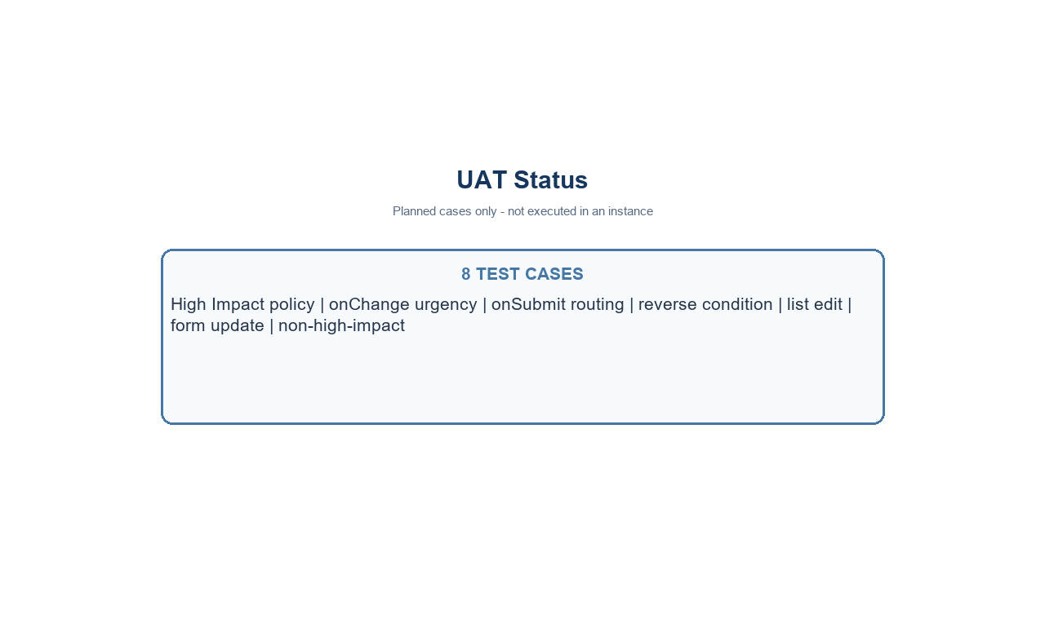
Conceptual project UI evidence - analytics tools not used
Project note: values use the standard Incident choices where Impact 1 and Urgency 1 represent High. Confirm field names and values in the target instance.

